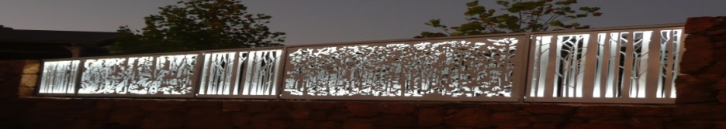
Pemberton Community organisation of the Year 2016.
www.pembertonartsgroup.org.au pembertonartsgroup.facebook.com
PAG NEWS: Contact Anna: czerkasow@antmail.com.au 0439 369 702
The Pemberton Art Prize 2022 - ‘HORIZON’. Photography by Corrina Barclay
The event was officially opened by Cr Murray Ventris. We kept the number of people attending down and complied with Covid-safe practices, though masks were removed for some of the photos.
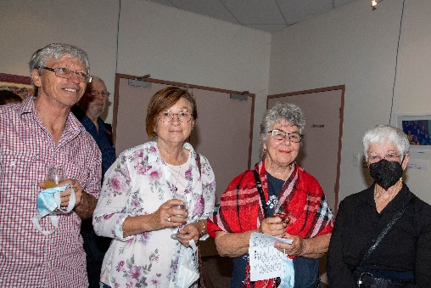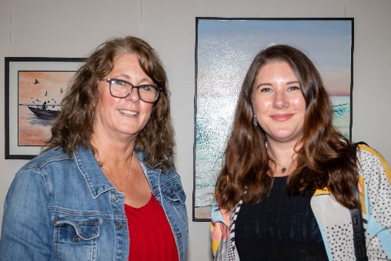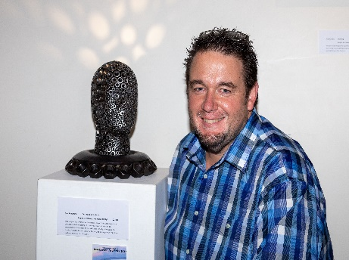
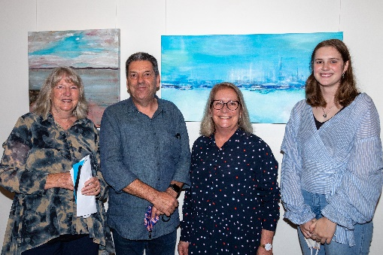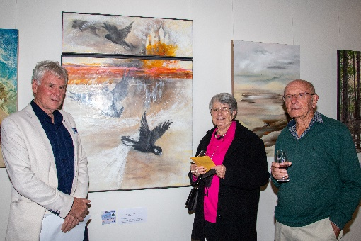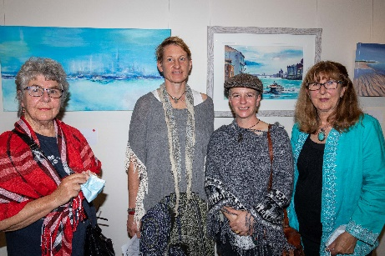
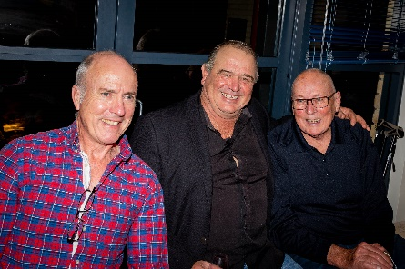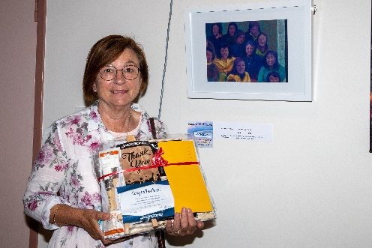
Awards: THANKYOU to all of our sponsors, supporters, artists and super volunteers!!
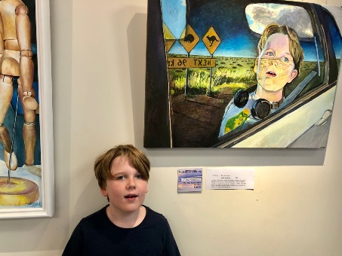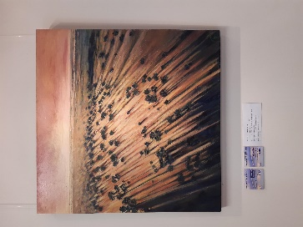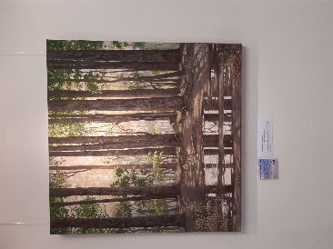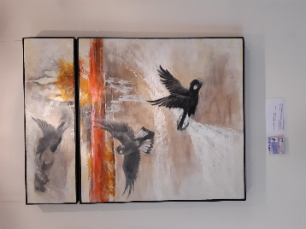

- $1 000 Ketelsen Art Prize: -#2 Vikki Cook – Shadows in Time
- $1 000 PAG Acquisitive (Torsten & Mona Ketelsen): -# 35 Janice Johnstone – “Glowing”.
- Bannister Downs Hand in Hand Open Acquisitive: - # 5 Lynley Lally
“Ether (noun: the region above the clouds).
- $500 Phil & Wendy French Art Prize: #6 - Barbara Maumill - “After the Storm”.
- OPS/Quantum Pacific Holdings $500 Art Prize: #14 – Paul Fontanini - “Expand Your Horizons”.
- $500 LJ Hooker Pemberton Manjimup Acquisitive Award: #9 - Jill Halden – “What Lies Beyond?
- $250 Shire of Manjimup Award (resident in Manjimup Shire): – #4 – Marilyn Barrington – “Danger on the Horizon”
- $250 Anonymous Award: - #8 - Diana Neggo – “Lake’s Edge”.
- Pemberton Best Western Hotel Prize $200: – #1 – Holly Lamey – “Oyster Catchers at Yeagarup”.
- Hon Jane Kelsbie MLA Prize: - #37 – Sam James – “Over the Horizon”.
- Jacksons Encouragement Award Gift Pack: - #20 - Karen Wiedemann – “Horizon – Self-Portrait”.
- $100 Voucher Treasures in the Forest Award: - #26 - Elke Paull-Keller - “Balance”.
- $100 Voucher Treasures in the Forest Award: - #31 - Pat Pattinson – “New Dawn On the Horizon”.
- Treehouse Tapas & Wine Bar $100 Voucher: - #2 – Vikki Cook - “Shadows in Time”.
- People’s Choice – Barbara Maumill’s “After the Storm”.
Colocation update:
Shona Erskine PHD
Everyone is Creative
All humans share the same spectrum for creative abilities.
When a person is provided with the appropriate conditions for learning, they have the capacity to learn what any person in the world can learn.
There is no difference in the creativity testing results between economically deprived or minority children and other children.

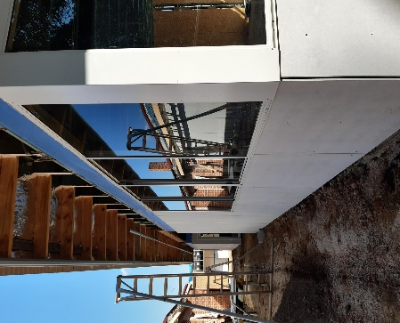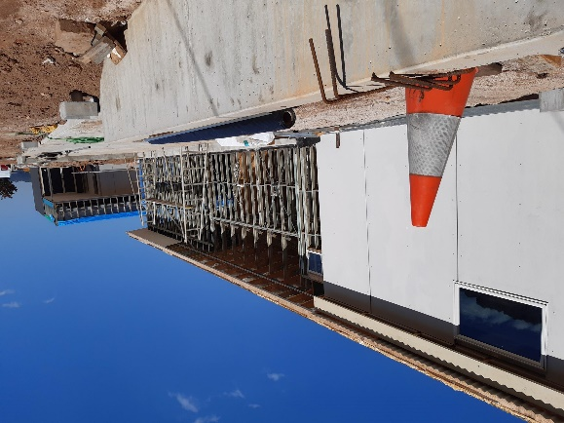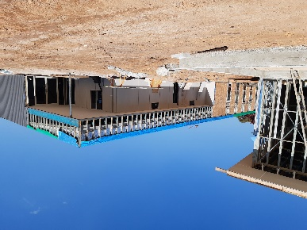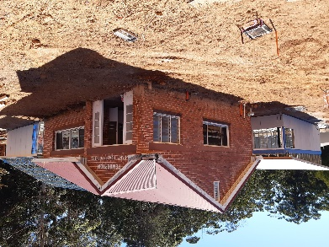
Art sessions
Wednesdays 9.30 - 12.30, at rear of CRC during school terms. Come along with your own project or try something new. We have lots of exquisite art books to give inspiration!
What’s Happening? Elmari Steyn’s exhibition at Painted Tree Gallery is not to be missed - in May.

