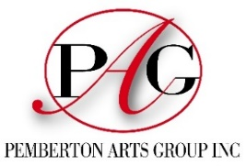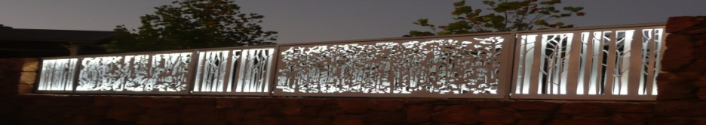
Pemberton Community organisation of the Year 2016.
www.pembertonartsgroup.org.au pembertonartsgroup.facebook.com
PAG NEWS: Contact Anna: czerkasow@antmail.com.au 0439 369 702
BEST WISHES TO ALL FOR A SAFE AND HAPPY FESTIVE SEASON FROM THE PEMBERTON ARTS GROUP COMMITTEE.
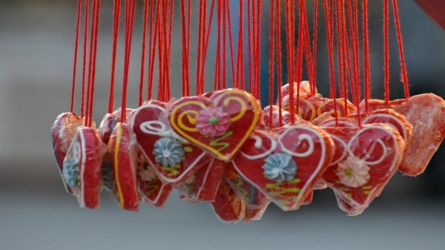
What’s happening:
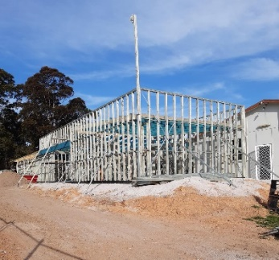
Students doing Community Service: A group of students from PDHS will soon be involved in Community Service in Pemberton, building on the wheels Christmas decorations by painting bicycles and large boards to tizzy up the town. Pemberton Arts Group is supporting the students’ worthy project with a donation for materials.

Photo: Co-location
Rear of Hall (RSL old Library).
Progressing slowly…
Nalda Searles’ Weekend Workshop: Fibre Art Retreat in Northcliffe
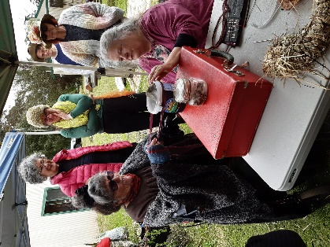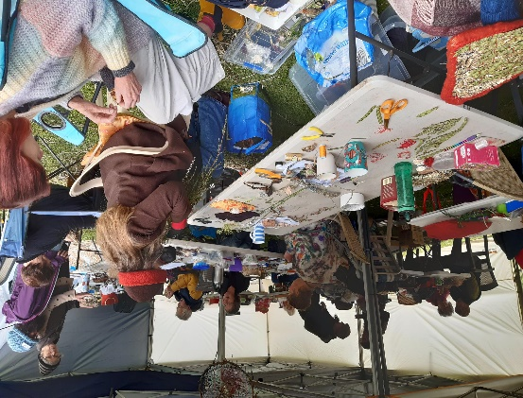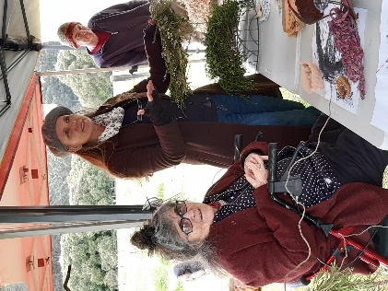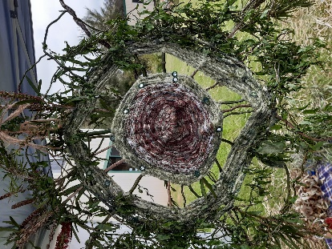
This weekend workshop at Karri Hill Cottages attracted 24 enthusiastic participants who capitalised on Nalda’s considerable knowledge, expertise and generous assistance to produce a range of creations in all sorts of fibres, threads, cloth and natural materials. It could only be described as a soul-nurturing experience for all - braving the inclement weather and happily connecting with each other and their creativity.
Rae Starr curated a showcase representing the culmination of a decade of Nalda’s workshops. Some of the works featured:
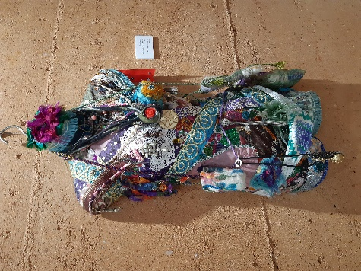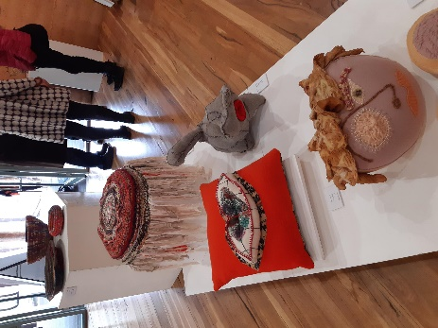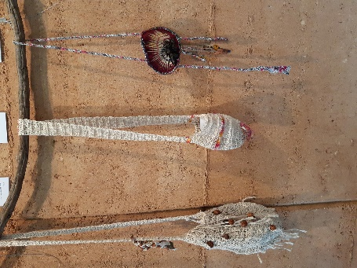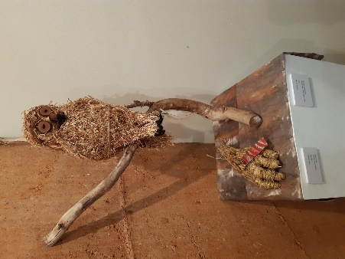
Painted Tree Gallery Exhibition: “We Must Get Together Sometime” opens on Sat Nov 27th
Manjimup: Cherry Harmony Festival Exhibition “Connected” at the Manjimup Gallery till December 15th.
Manjimup Art Award workshop “Connections”, presented by John Garde and subsidised by Southern Forest Avocados, was held on the 27th November at the Wellness Centre. Sixteen participants produced abstract creations and learnt about what works and why with some valuable tips.
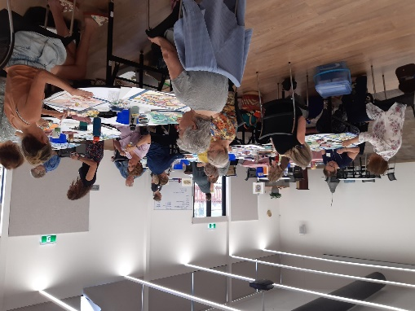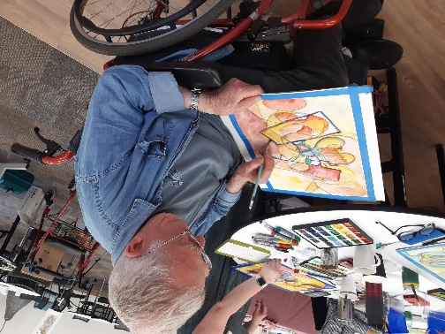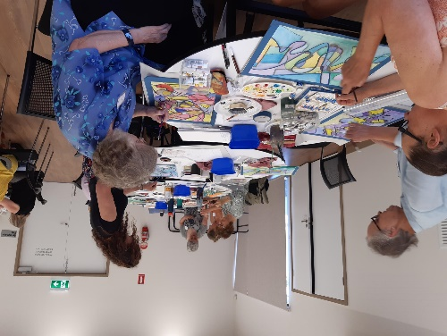
Art Sessions: Wednesdays, 10am start. No sessions during school holidays. Bring your own project or try something new. We have a great collection of resource art books – thanks to generous donors. Call first to make sure we haven’t changed our plans.
Photos: Anna Czerkasow

