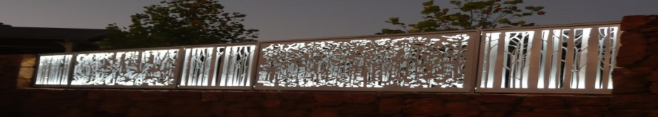
Pemberton Community organisation of the Year 2016.
www.pembertonartsgroup.org.au pembertonartsgroup.facebook.com
PAG NEWS: Contact Anna: czerkasow@antmail.com.au 0439 369 702
CO-LOCATION: Site works are gradually progressing – despite the rain! The project is expected to be completed by June 2022.
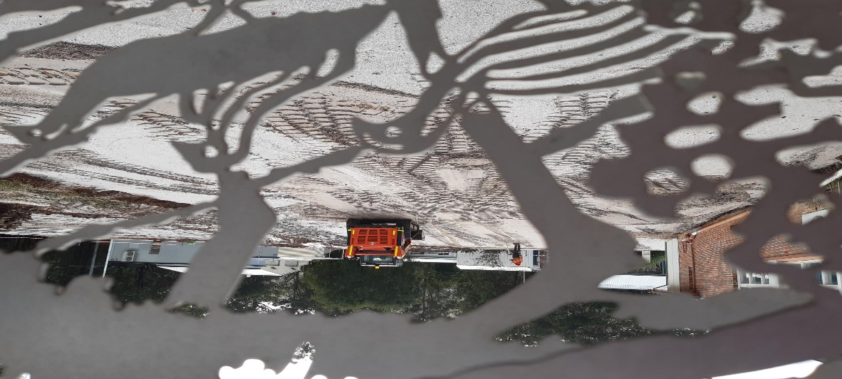
THANK YOU: The PAG committee hosted a Sundowner at Jill & Rob Baker’s home to acknowledge our sponsors, members and volunteers who all contribute to the success of our events. Special thanks to Jill & Rob for their generous hospitality! We plan to celebrate our loyal volunteers and sponsors again later in the year to capture those who couldn’t make it this time. With our 18th Annual Spring Exhibition coming up, please let us know if you’d like to sponsor an award.
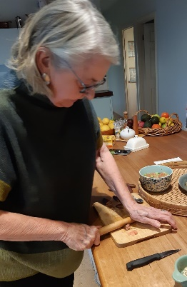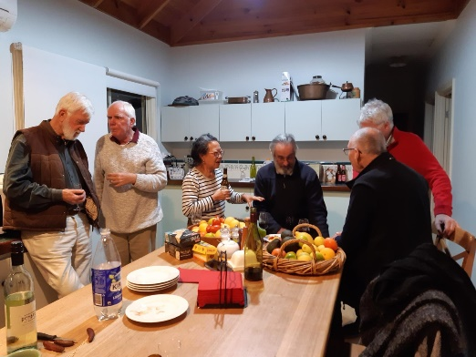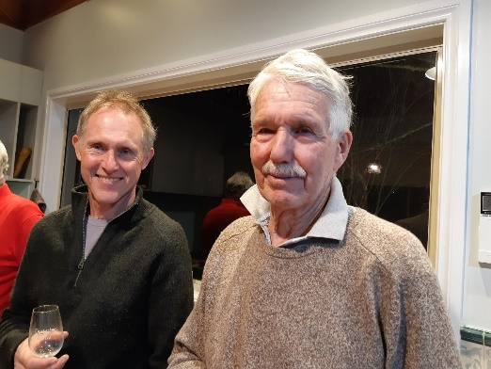
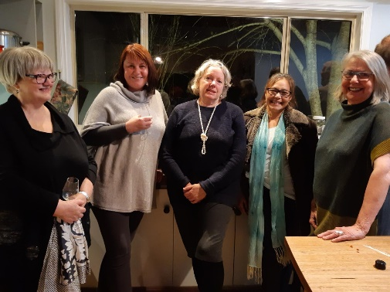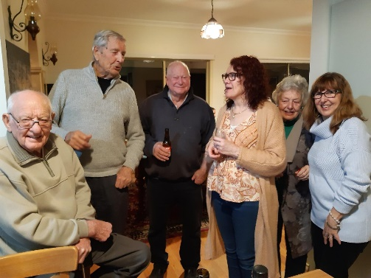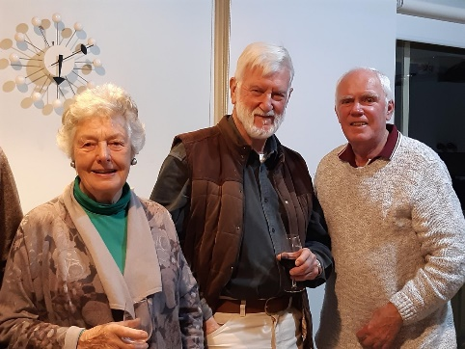
PDHS ARTS FESTIVAL: What a fantastic showcase! Congratulations to all who organised or contributed to this wonderful opportunity for Pemberton’s youth. It will be great to see their talents develop in the future. Below are snippets of the students’ creations.
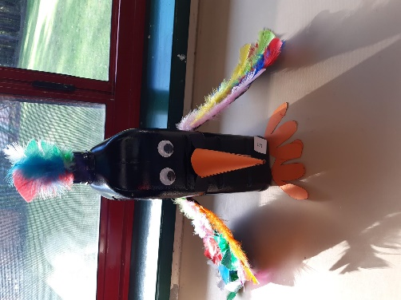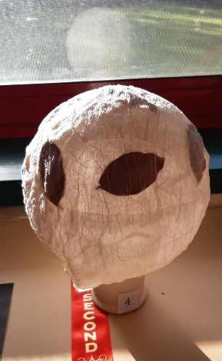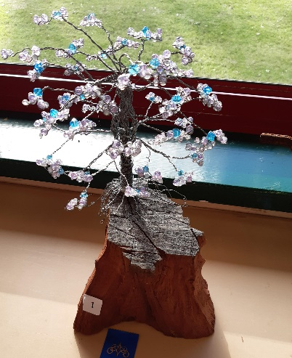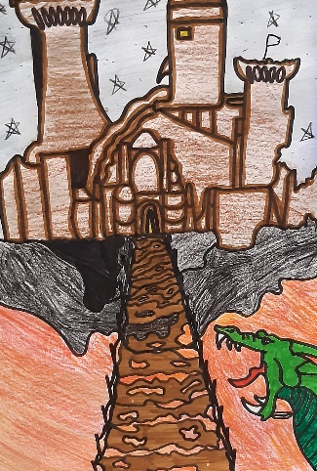
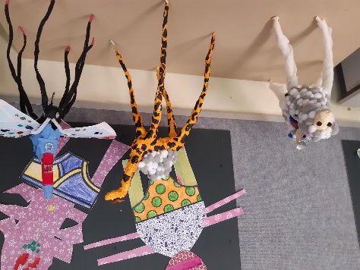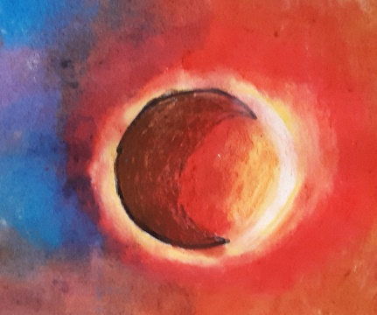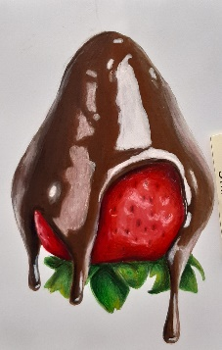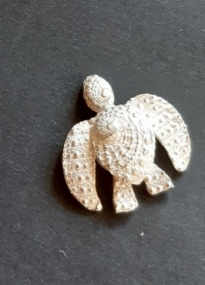
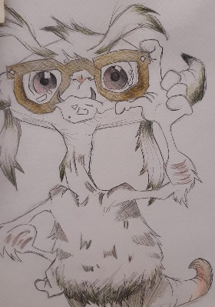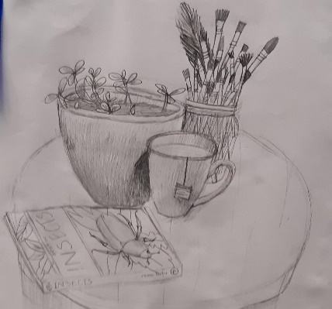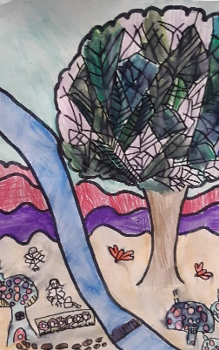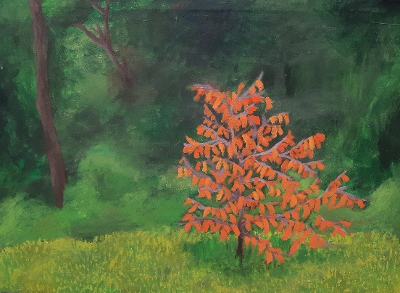

What’s on:
LJ Hooker Pemberton: Sue Fellows’ thought-provoking art. Two sets of 5 paintings have been installed: a series of pears and a spiritual series – all beautifully crafted.
Manjimup Art Gallery – Noongar Art Exchange Exhibition opens July 3rd.
Painted Tree Gallery Northcliffe: - he-she-they-exhibition till mid July.
Art Sessions: Changing the time for winter sessions on Wednesdays to a 10am start. No sessions during school holidays. Bring your own project or try something new. We have a great collection of resource art books – thanks to generous donors. Call first to make sure we haven’t changed our plans.
Photos: Anna Czerkasow & Paul Nolan

