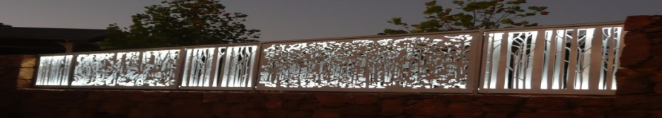
Pemberton Community organisation of the Year 2016.
www.pembertonartsgroup.org.au pembertonartsgroup.facebook.com
PAG NEWS:
What’s on:
Don’t be shy: Pop in to see Sue Fellows’ thought-provoking art at LJ Hooker Pemberton. Two sets of 5 paintings have bee installed: a series of pears and a spiritual series – all beautifully crafted.
Sue has experimented with changing the colour of the pears in her series from what we generally perceive as being ‘true’ to something quite different. See for yourselves!!
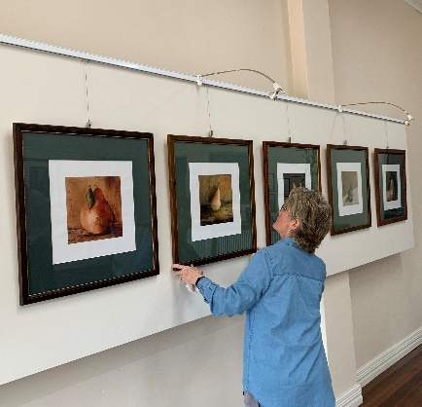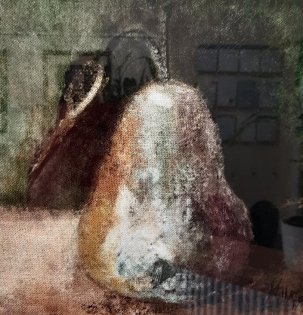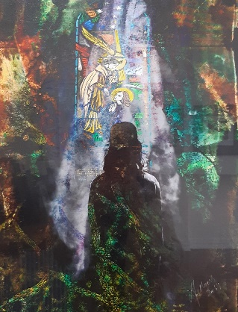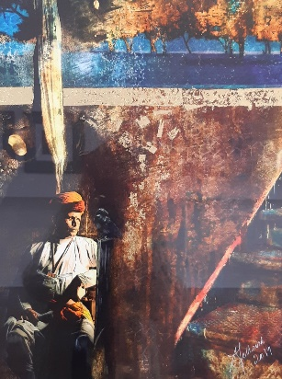
(Photo: E. Steele) (Photos: A. Czerkasow)
Exhibition of Tony Windberg’s stunning works at the Art Collective in Perth.
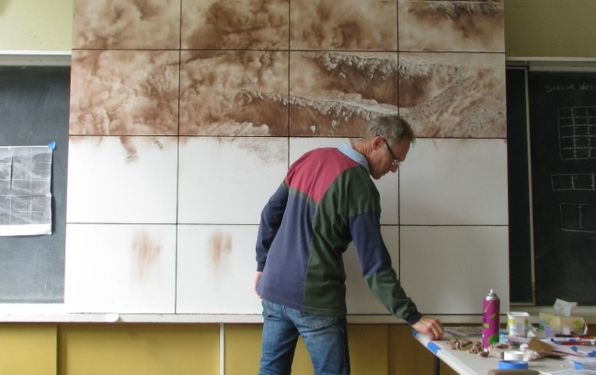 (Photo: T Windberg)
https://artcollectivewa.com.au/artists/tony-windberg/
Manjimup Gallery – ‘Friends Old and New’ – ends June 19th.
Art Sessions: Changing the time for winter sessions on Wednesdays to a 10am start. No sessions during school holidays. Bring your own project or try something new. We have a great collection of resource art books – thanks to generous donors. Call first to make sure we haven’t changed our plans.
The Bigger Picture: The Alternative Archive Exhibition
The Alternative Archive is part of a larger Regional Arts Partnership Program linking regional artists and fostering arts development across the state. Artists in 14 communities throughout regional WA staged their own exhibition resulting in a series of individual yet interconnected displays.
The Alternative Archive: Nectere (Latin for tie or bind) – exploring how we personally connect to place.
In the Manjimup Shire: Fay Dunstan and I (Anna Czerkasow) culminated our curating menteeship in June 2019 with an exhibition of diverse works created by 39 artists from the Manjimup region. Corrina Barclay, our official photographer, was mentored by Brad Hanrahan to record the project. From this exhibition, works by Claudette Mountjoy, Lizzie Troup and Louise Tasker were selected to be part of the Alternative Archive Exhibition currently showing at John Curtin Gallery.
Co-curated by Chris Malcolm (Director, John Curtin Gallery) and Anna Louise Richardson (Independent curator/artist), the exhibition is the culmination of an ambitious three year project to present a series of regional exhibitions, bearing the Alternative Archive name, which were held between February and October 2019. The Alternative Archive series encompassed 13 venues, 26 curators and 206 artists from as far away as Kununurra and Esperance.
The Alternative Archive was originally developed through Connect to the Creative Grid, an initiative of the Regional Arts Partnership Program supported by the State Government of WA and Country Arts WA with additional funding support from the Australian Government through the Regional Arts Fund.
Take a bow Fiona Sinclair-Hill for your role in this ambitious, inspirational and innovative project!! Our region benefits greatly from having your advocacy and representation in WA’s arts sector.
Exhibition and Symposium Highlights:
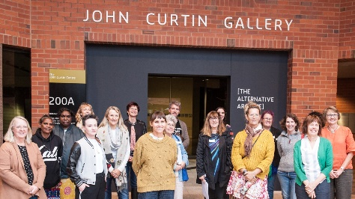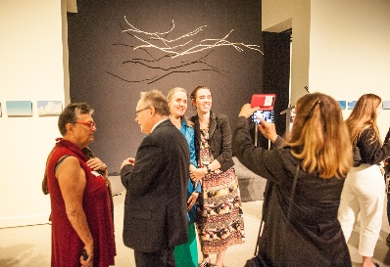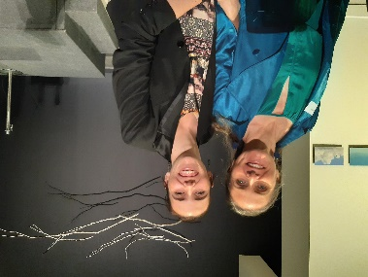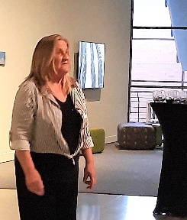
Alternative Archive Curators ( Photos J Bowron) Hon D Templeman Fiona & Anna-Louise (Photos A Czerkasow) Claudette
John Curtin Gallery
Curtin University, Perth, Australia
jcg.curtin.edu.au
Gallery opening hours:
Mon to Fri: 11am - 5pm
Sun: 12 - 4pm
Exhibition open to the public from Friday 14 May – Friday 30 July

Contact Anna: czerkasow@antmail.com.au 0439 369 702

