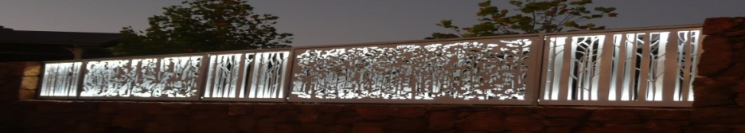
Celebrating 20 Years!! Sincere thanks to our volunteers, members, sponsors and supporters.
www.pembertonartsgroup.org.au pembertonartsgroup.facebook.com
PAG NEWS: Contact Anna: pembertonart2023@outlook.com 0439 369 702
Our Committee:
Anna Czerkasow – Chair; Sean Tysoe – Deputy Chair; Jeanette Evill – Secretary; Jill Baker – Treasurer;
Fay Dunstan; Lisa Radomiljac; Tony Windberg; Paul Nolan.
Art Classes with Tony Windberg:
Watch out for more class options once we’re in the new Community Arts building (Balang Miya Community Hub).
Currently Tony’s class is learning about light, shade, tone & colour and how they all interact and affect each other. Han’s Heysen’s works have been looked at closely and analysed. George Haynes’s use of colour to capture light also inspires!!
Individual projects incorporating the techniques learnt are now underway.
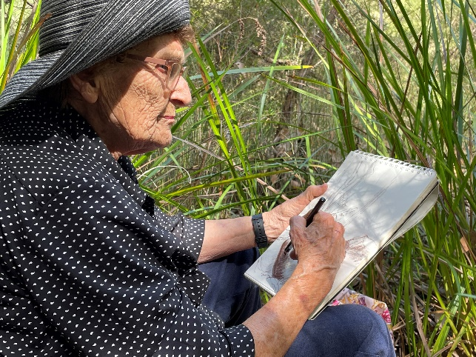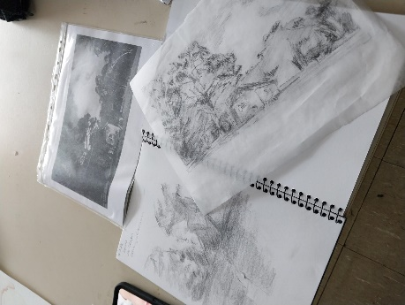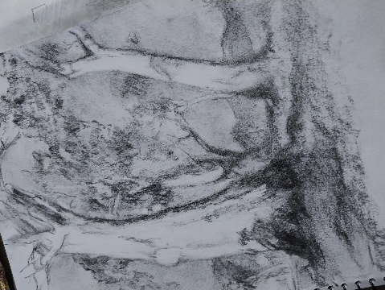
Gwen sketching - Big Brook. Tonal Studies. .
Photo: Tony Windberg. Photos: A. Czerkasow
Wednesday Art Sessions
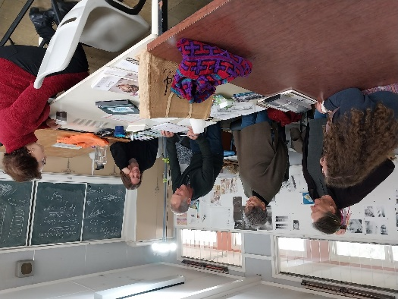

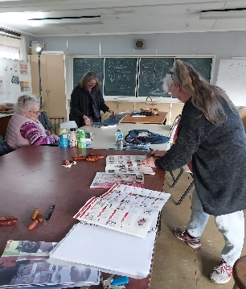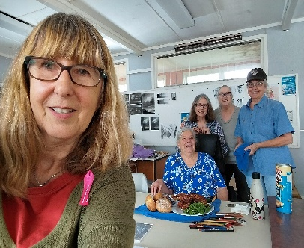
Art Class demo – watercolour techniques Engaged. After session - Sue’s birthday celebration.

