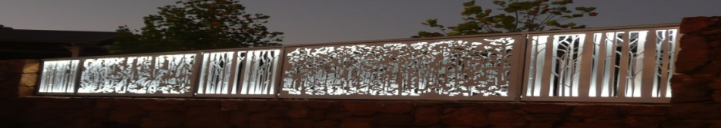
Pemberton Community organisation of the Year 2016.
www.pembertonartsgroup.org.au pembertonartsgroup.facebook.com

PAG NEWS:
Pemberton Art Prize 2021 and Pemberley Sculpture in the Vines:
Look out for the posters. These will be invitation only events, hopefully without more Covid restrictions.
Sincere thanks to all of our sponsors for the upcoming exhibitions. Artist entrants regularly express their appreciation of the donors and sponsors who contribute so much to the success of the events.
Make sure you look out for information about these exhibitions in April.
Co-location update: Completion date for the project has been put back to around February 2022. Separtate enders have been accepted for the main co-location work and Little Taddies.
New works:
Solo display of Elaine Steele’s monoprints & paintings at LJ Hooker Pemberton.
Manjimup Gallery until March 26: Botanical art exhibition – ‘North and South’ – includes works by Pat Dundas.
Ineffective Coping: (Courtesy of Dr Shona Erskine, Sarah Borg & Adrian Shonfeld)
Are you coping with all that life throws up at you? Not coping can get you into trouble if you’re:
- Avoiding the problem
- Procrastinating
- Using alcohol and other drugs
- Spending too much time on social media in place of human interactions
- Watching hours of on-line videos in place of acting in the world.
Sometimes people will use a coping strategy that feels like it reduces stress levels but in reality makes them more stressed in the long run.
Try Creative Activities such as (just to name a few…):
- Colouring in
- Drawing and painting
- Zentangles
- Decorating clothing or household items to give them a ‘facelift’
- Doing puzzles
- Embroidery
- Collaging
- Cooking
Art Sessions: Come and join us on Wednesdays 9.30 am – 12.30 pm except school holidays. Bring your own project or try something new. We have a great collection of resource art books – thanks to generous donors.
Contact Anna: czerkasow@antmail.com.au 0439 369 702
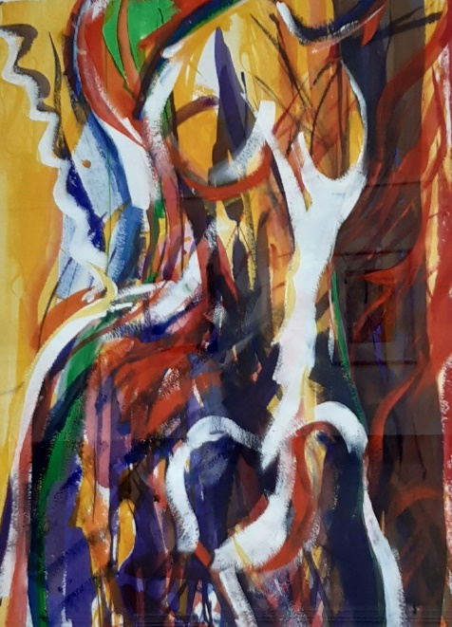 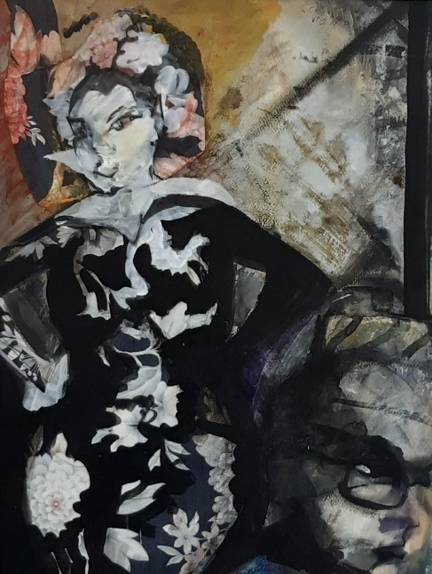 Detail, Elaine Steele.
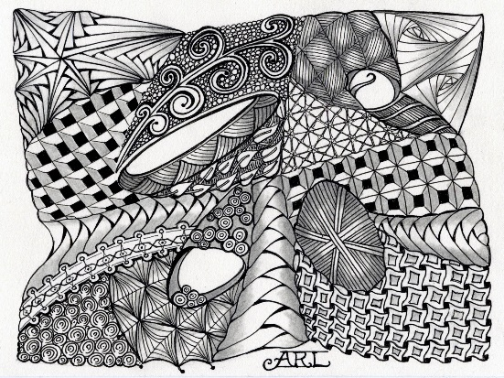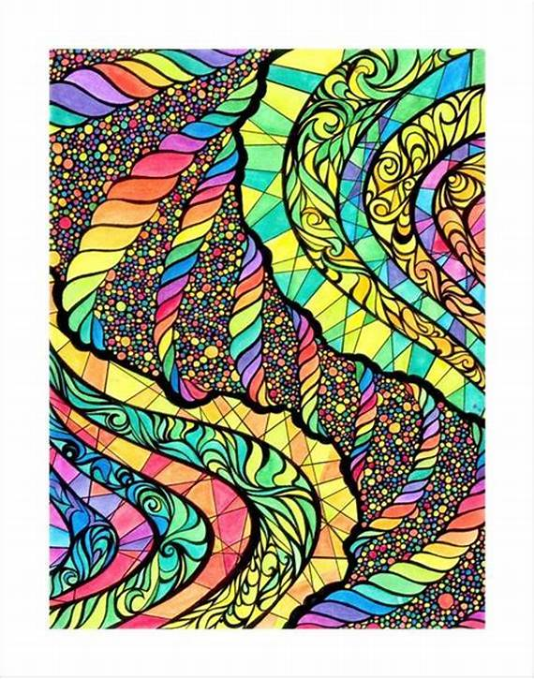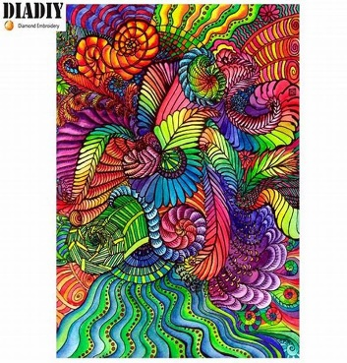
Examples of Zentangle Art

