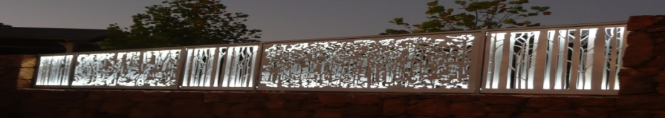
Pemberton Community organisation of the Year 2016.
www.pembertonartsgroup.org.au pembertonartsgroup.facebook.com
PAG NEWS:
Pemberton Art Prize 2021
The official opening of the Pemberton Art prize – ‘Boundaries’ – exhibition was a tremendous success, with the maximum 100 in attendance. Sincere thanks to our amazing team, sponsors, artists and supporters. Our generous, dedicated volunteers ensured that the exhibition was open to the public for the duration of the school holidays. Sincere thanks to all who helped!!
Twelve very happy artists moved their art on to new homes. Visitors to the exhibition included locals, artists, interstate and overseas tourists. Many commented on the artists’ varied interpretations of the theme ‘Boundaries’.
Prizes:
Bannister Downs Hand in Hand Acquisitive $1 500 - # 15 - Gay Scaddan – ‘Leaf Fall’ – oil, acrylic
Ketelsen Art Prize - $1 000 - # 21 - Marion Nelson - ‘Brilliant Sunrise’- linocut with gold leaf
PAG Acquisitive (Torsten & Mona Ketelsen) - $1 000 - # 31 - Elmari Steyn – ‘Childwoods VII’ – multiple plate etching, Chine colle & hand painting
Phil & Wendy French Art Prize - $500 - # 5 - Paul Fontanini – ‘Casting With Nature – Termites 2, Music From The Mound’ – cast aluminium, steel, York gum burl
RAC Karri Valley Acquisitive $500 - # 20 Jane Dickason – ‘Katherine on High’- acrylic
LJ Hooker Pemberton Manjimup Award $300 - # 29 Dee Credaro – ‘Farmstead 140’ - inks
Shire of Manjimup Award $250 - # 14 Marilyn Barrington – ‘Strange Times’- encaustic, multi-media
Pemberton Best Western Hotel Prize $200 - # - Anna Czerkasow - ‘Bound By Sea’ – acrylic on canvas
Jacksons Encouragement Award - $200 gift pack - # 19 - Sean Tysoe – ‘Wall Ride’ – acrylic on canvas
Treasures in the Forest Award $150 Voucher - # 23 - Lesley Barrett - ‘Don’t Fence Me In’
People’s Choice Award $200 – Elmari Steyn
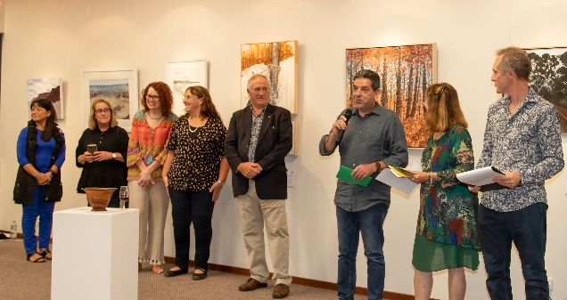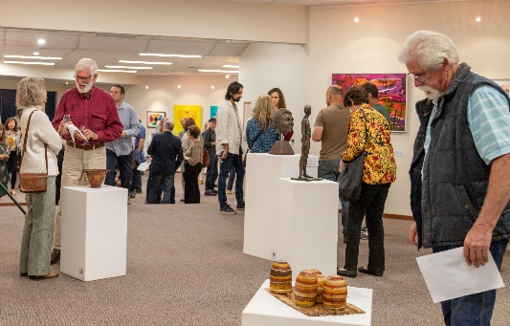
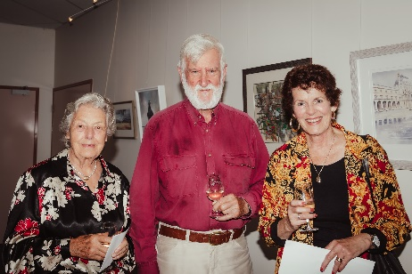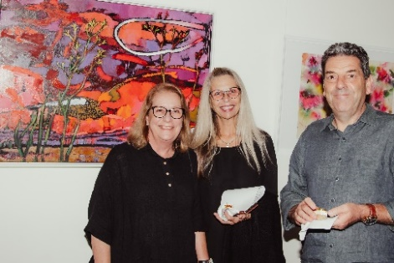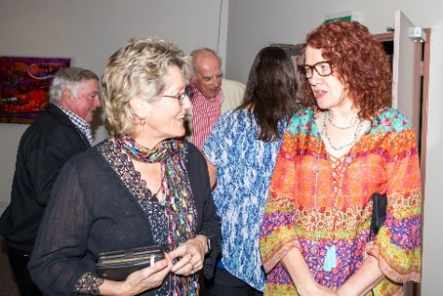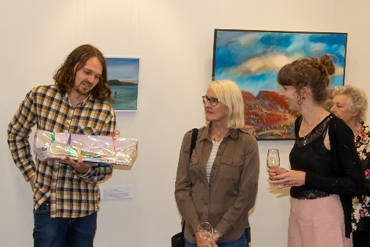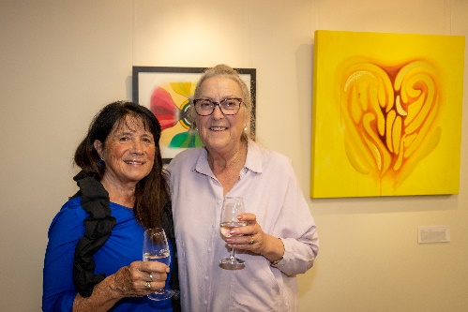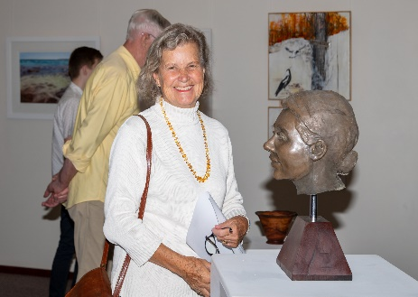
Pemberley Sculpture in the Vines:
On a perfect autumn Friday evening, Pemberley Sculpture in the Vines was officially opened by the Hon Jane Kelsbie MLA. The sculptures looked sensational against the backdrop of colourful vines and setting sun. An impressive 4.8m high sculpture titled ‘Looking to the Future, Remembering the Past’ – by Paul Fontanini – was selected as the acquisition by the Manjimup Shire and Pemberton Arts Group. Congratulations to Paul for his passion, skill and creativity in making this sculpture and for being recognised at other prestigious exhibitions.
Within the marquee was a stunning collection of sculptures created by students from Pemberton DHS, Manjimup SHS, Kearnan College and Bridgetown HS. These works are a credit to the students and their teachers. Judges found it difficult to select awards because of the high standard of works submitted.
A group of about 30 students from Manjimup and Pemberton attended Pemberley where, after walking through and discussing the exhibition, they listened to guest speaker and sculptor Peter Hill and asked questions about sculpting and art. After a brief Awards ceremony, students worked on a paper sculpting activity.
Close to 700 visitors enjoyed this exhibition before it closed on the 26th April.
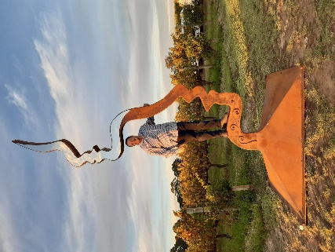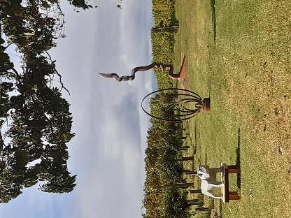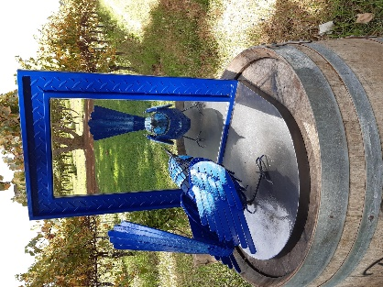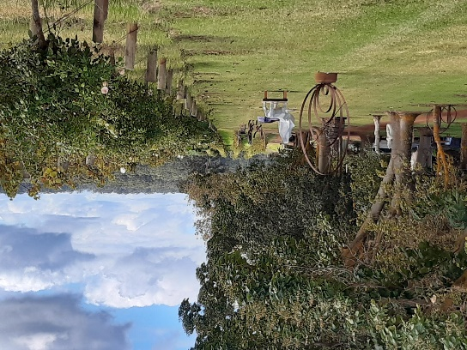
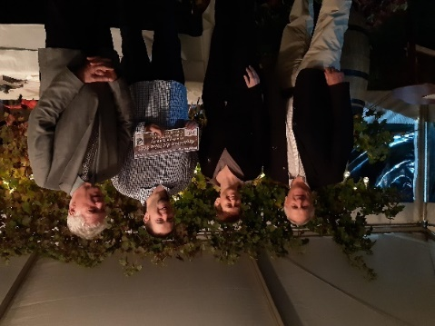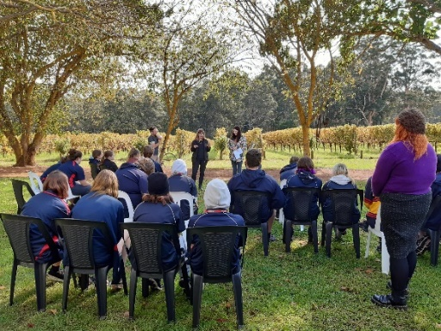
What’s on:
Elaine Steele’s monoprints & paintings at LJ Hooker Pemberton.
Exhibition at Mountford’s – ‘Aspects’
More to see at Painted Tree in Northcliffe and Bunbury Regional Gallery!!!
Manjimup Gallery – ‘Friends Old and New’ – exhibition opens 14th May.
Art Sessions: Come and join us on Wednesdays 9.30 am – 12.30 pm except school holidays. Bring your own project or try something new. We have a great collection of resource art books – thanks to generous donors. Call first to make sure we haven’t changed our plans.
Contact Anna: czerkasow@antmail.com.au 0439 369 702

