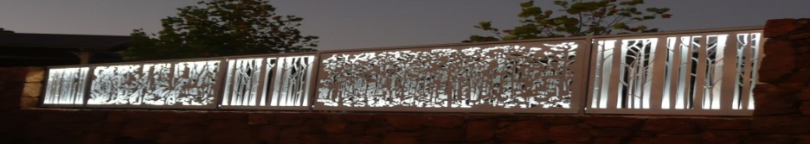
Pemberton Community organisation of the Year 2016.
www.pembertonartsgroup.org.au pembertonartsgroup.facebook.com
PAG NEWS: Contact Anna: czerkasow@antmail.com.au 0439 369 702
What’s happening:
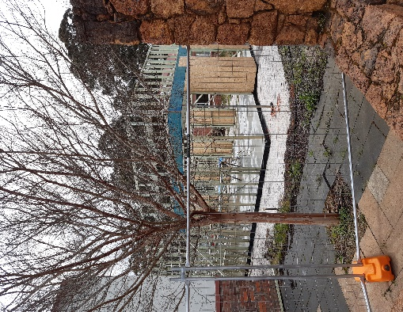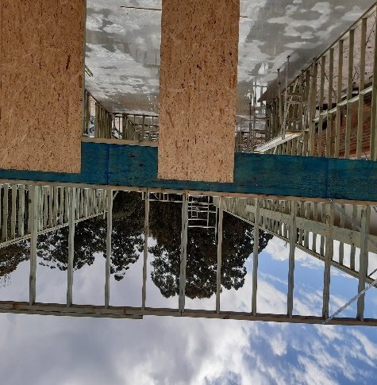
Photos: Progress being made on the Co-location project which is now likely to be completed in September 2022. Stakeholders are currently finalising quotes for the Lotterywest grant submission. – Not an easy task as prices are rising and contractors are extremely busy.

Crochet Sculpture Workshop:
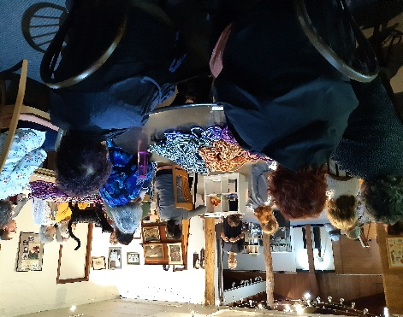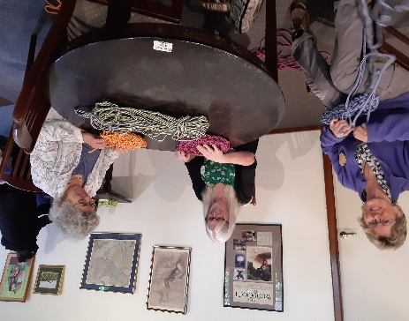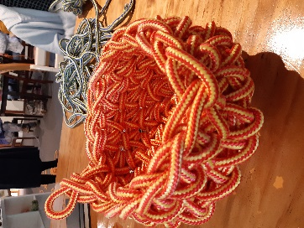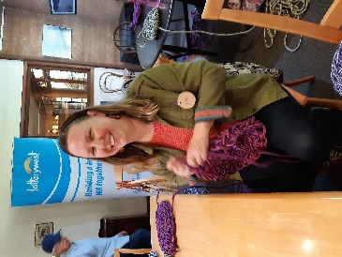
It was a full house at Fine Woodcraft Gallery for Mikaela Castledine’s “Thinking In 3D” crochet sculpture workshop. Attendees came from all towns of the Shire and a group of ladies even travelled from Bunbury! It will be interesting to see what eventuates from the workshop.
Sincere thanks to Ros Piper for the use of the gallery and Jill Baker for organising the superb morning tea and lunch.
Northcliffe: Nalda Searles’ significant influence will be celebrated in an exhibition of her 11 years of connection to the Northcliffe community. Check the Southern Forest Arts website for details.
Nalda Searles’ Fibre Art Retreat, 5 – 7 Nov – “Seeds of the Mind’: Participants from Perth, Dwellingup, Manypeaks, Pemberton, Manjimup, Quinninup, Peppermint Grove Beach, Balingup, Bunbury and of course, Northcliffe will spend 3 days exploring their creativity under Nalda’s guidance at Karri Hill Cottages. Promises to be an amazing experience!
Sewing in the Forest with Nalda: Create your own bee or bird with stitch and fabric. 2 – 4pm, Sun Nov 7 at the Painted Tree Gallery. $15 adults, $10 under 18 & SFA members. Bookings through Southern Forest Arts website.
Painted Tree Gallery Exhibition: “We Must Get Together Sometime” opens on Sat Nov 27th
Manjimup: Creative Leadership Workshop, Cherry Harmony Festival coming up.
ArtGeo Gallery, Busselton: ‘Drawing in Space’ – Mark Grey-Smith - till 14th Nov.
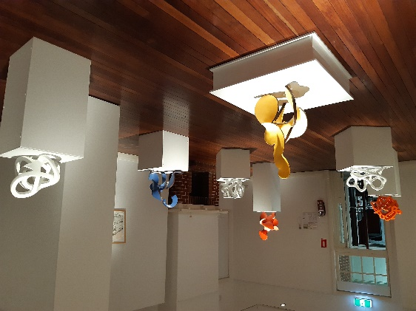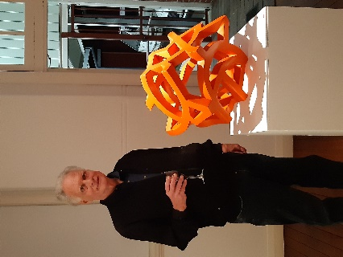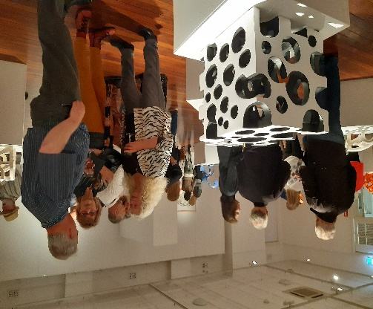
Art Sessions: Wednesdays, 10am start. No sessions during school holidays. Bring your own project or try something new. We have a great collection of resource art books – thanks to generous donors. Call first to make sure we haven’t changed our plans.
AGM: Held on Wednesday October 27^{th,} Charlies (Pemberton Hotel). Elected committee members – Anna Czerkasow, Sue Fellows, Jeanette Evill, Jill Baker, Elaine Steele, Joy Head, Tony Windberg, Paul Nolan and Fay Dunstan. Thanks to all who attended!
Photos: Anna Czerkasow

