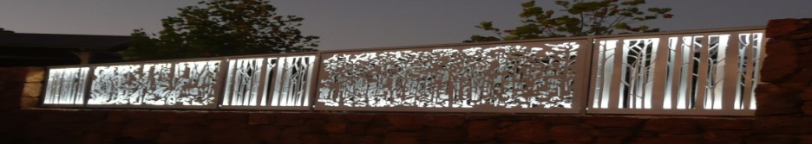
Pemberton Community organisation of the Year 2016.
www.pembertonartsgroup.org.au pembertonartsgroup.facebook.com
PAG NEWS: Contact Anna: czerkasow@antmail.com.au 0439 369 702
Please contact PAG if you wish to donate, sponsor a prize in our exhibitions or become a member.
Check our website for entry forms to our exhibitions, info about events and links to video footage – Rob Baker’s Photography Exhibition & Paul Fontanini’s video of his sculpture installation.
New in Town:
Bullock team on show opposite the Mill Hall. Thanks to the Hemsleys for their efforts in installing this new Pemberton attraction, value-adding to the existing historic display.

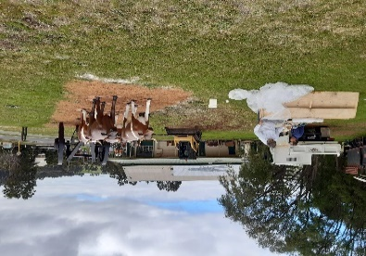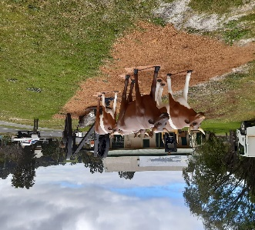
Balang Miya – Pemberton Community Hub:
The latest update indicates that the build could be completed around January – February, though probably best to consider April as the finish date. Happy to be wrong!!
Worth Seeing:
Pemberton Arts Group’s 19th Annual Spring Exhibition – “Transience” – on show during the school holidays. Don’t miss it! Open daily from 10am – 4.30pm September 24 – October 9. Let me tease you with these snippets:
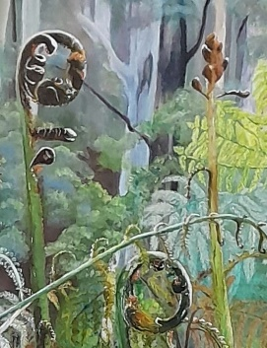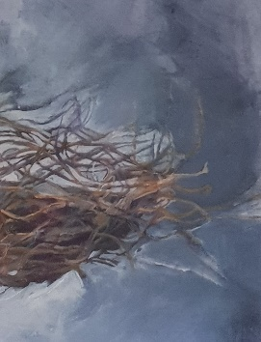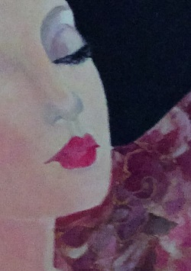

Tony Windberg’s ‘Wonders of the Worlds’ exhibition will show at Albany Town Hall from September 23 to October 28 https://artsandculture.albany.wa.gov.au/venue-info/albany-town-hall.aspx
Mark Grey-Smith’s Exhibition -
Renowned local sculptor Mark Grey-Smith will be exhibiting at the University of Western Australia (UWA) Undercroft Winthrop Hall this month. The exhibition will include a number of science-inspired sculptures inside and outside the Undercroft, together called Drawing in Space, and is part of the UWA’s centenary celebration of the Wallal eclipse expedition, an iconic event which proved Einstein's theory of relativity. Entry is free, and the exhibition will run from Wednesday 21 September until Sunday 2 October 2022. For details see https://www.uwa.edu.au/study/Events/UWA-Wallal-Expedition-Centenary
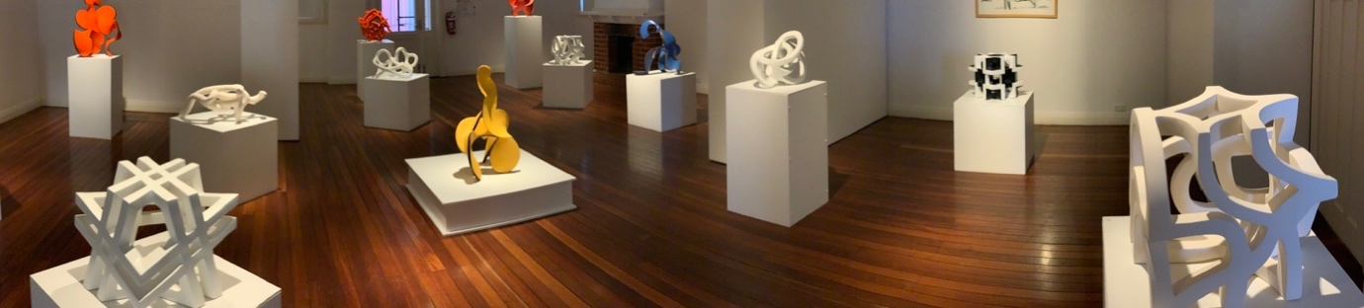
Image 1 details:
Mark Grey-Smith Drawing in Space Exhibition 2021 (Works from 2018-2021), Art Geo Gallery, Busselton.
Image Credits: David Blair

Painted Tree Gallery:
Watch out for the Southern Forest Photography Club’s exhibition in September.
Understory, Northcliffe:
When’s the last time you walked through the Understory Sculpture Park in Northcliffe?? 2 more recent exhibits shown right. Well worth the effort. I guarantee you won’t be disappointed with the impressive trees and natural environment either.
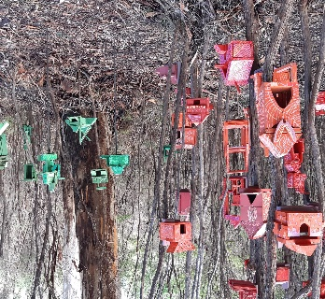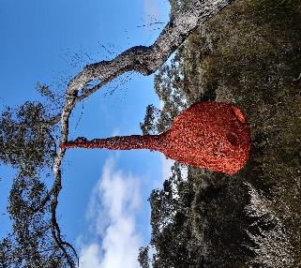
Art sessions: Wednesdays now 10.00 – 1.00, at rear of CRC during school terms. Come along with your own project or try something new. Try some Gelli printing, marbling, adding gold leaf or just get into some sketching or pastel drawing. Lots of exquisite art books to give inspiration too!
THANKYOU to all of our sponsors, supporters, artists and super volunteers!!

