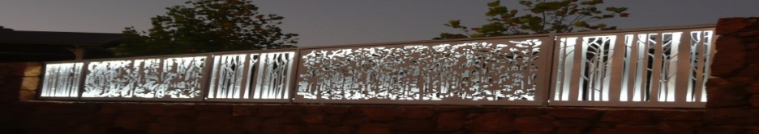
Pemberton Community organisation of the Year 2016.
www.pembertonartsgroup.org.au pembertonartsgroup.facebook.com
PAG NEWS:
DON’T Forget…To our sponsors, members and artists who receive an invitation to the 17th Annual Spring Exhibition - you must RSVP with your acceptance as numbers attending the opening event are strictly limited due to Covid restrictions.
Where are we now?
Pemberton locals will soon have the opportunity to see plans for the colocation project which will provide amenities for our whole community. Our Arts Group (PAG) anticipates that the new spaces will encourage community members and visitors to use and enjoy the facilities. For us, the Community Arts area in particular will enable local artists and community members to meet, engage and create art in a venue suitable for a wider range of activities and attracting a broader range of age groups than is currently possible.
We aim to acquire sculptures over time to enhance the outdoor spaces and the appearance of the Community Arts building by adding artistic features. Apart from that we will contribute to the shared facilities, provide required furnishings and insulate our storage shed to ensure the safe-keeping of stored equipment and materials. We will also contribute the $3 300 funds from the now defunct PCARC to landscaping & beautifying the area for the benefit of the whole community. Undoubtedly there will be many additional expenses to consider!
Sponsors, Artists & Community:
Without the support of sponsors (especially the Shire and local businesses), artists and community, we would be unable to provide Arts opportunities and experiences for artists, local residents and visitors.
A HUGE THANK YOU to all of you for your support and contribution to the Arts Culture in Pemberton!! Make sure you come to view the 17th Annual Spring Exhibition and support an artist by purchasing a work. In centuries to come, it will be the art that survives when all else has passed.
SPECIAL THANKS to Max Hewitt whose inspiring designs opened our eyes to possibilities.
New works: (still life & landscapes) can be viewed at LJ Hooker Pemberton.
Art Sessions: Wednesdays 9.30 am – 12.30 pm. Bring your own project or try something new.

