Tribute to Ron Ashton: 11.11.1939 – 29.04.2023
Local identity Ron Ashton died recently after a serious fall.
Dancer, producer, director, adjudicator, consultant, artist, poet, philosopher, master of languages….Ron’s dance career, spanning 50 years, began with ballroom dancing when he was 19. From there he readily adapted to various dance styles, teaching and backstage work. His enduring partnership with Kaye saw them work and travel extensively throughout South Africa, West Germany, Switzerland - among other countries – and work with high profile performers, including Margot Fonteyn.
Once settled with his family in Pemberton, Ron continued to dance, choreograph and teach. He spent several years working in Singapore and Victoria then returned home where he taught dance and Pilates classes in a number of towns.
In his 70’s, Ron developed his unique drawing style using ink & pencils. Some of the more recent highlights of Ron’s diverse talents are: solo art exhibition ‘Pas de Deux’ (Dec 2015 – Jan 2016) at Painted Tree Gallery, performing in Don Quixote (Quarry Theatre), Sleeping Beauty and Coppelia (Her Majesty’s Theatre), and his role as the Priest in “Jasper Jones” (2018).
Ron has left us with many fond memories and stories. Our thoughts are with his family and friends.
A service will be held on the 9th June, 11am at the Warren Community Church in Manjimup.
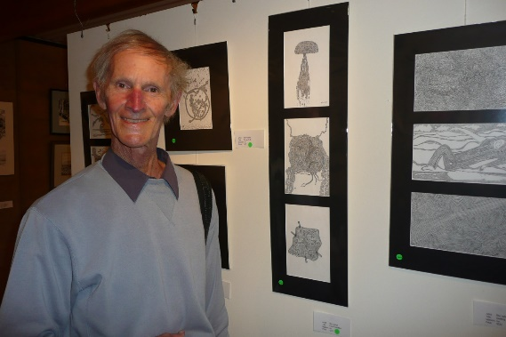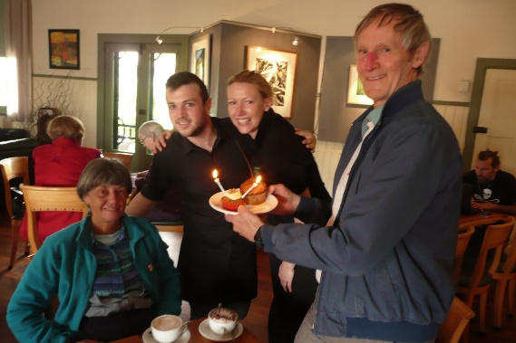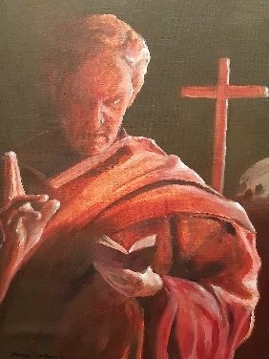
1.With his art at Pemberton Wine Centre Exhibition. 2. Kaye’s birthday celebration. 3. Model for art class.
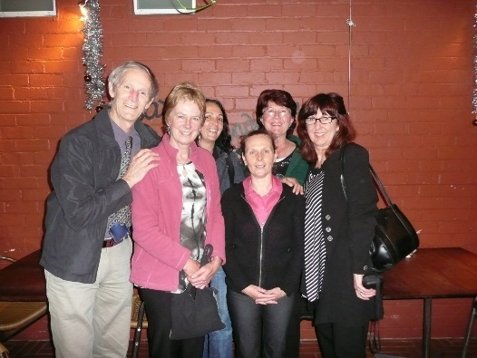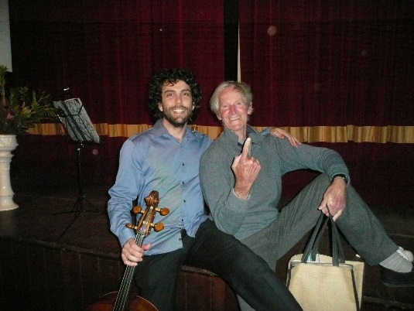
Photos and text by Anna Czerkasow.
4. Senior’s dance class. 5. With Anthony Albrecht, Mill Hall, where Ron performed an impromptu dance.

