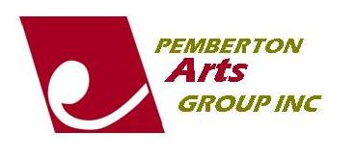 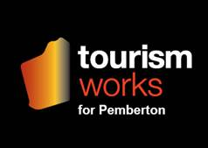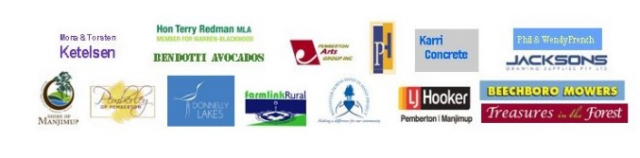

*Pemberton Community organisation of the Year 2016.*

***Award winners unearth discover embrace Pemberton Art Prize 2018:***

Hand In Hand sponsored by Bannister Downs Dairy – Barbara Maumill for “Whispers”

Mona & Torsten Ketelsen $1 200 Art Prize – Mark Grey-Smith for “Return”

Mona & Torsten Ketelsen $800 Merit Award – Peter Kovacsy for “Close Ties”

Pemberton Hotel Acquisitive – John Duncan – “The Shape of Water”

Phil & Wendy French $600 Art Prize – Barbara Maumill for “Whispers”

Karri Concrete Acquisitive – Lynley Lalley – “Rough Day At Sea”

Donnelly Lakes Acquisitive – Joanna Box – “Woylie”

Pemberton Arts Group Acquisitive – Lesley Barrett – “Unfaithful Wench”

LJ Hooker Pemberton & Manjimup $300 Prize – Michael Miller for “Boodjar Kabi”

Shire of Manjimup $250 Prize – Sarah Bondini – “Racing in the Rain”

Treasures in the Forest $150 Voucher – Suzanne Fellows for “Hidden Hens”

$200 Curator’s Award donated by Beechboro Motors – Jann Barry for Warrior of the Dreamtime”

Jacksons Drawing Supplies Encouragement Award – Carol Hackett for “Just Cruisin”

**Pemberley Sculpture in the Vines Award Winners:**

$5 000 Shire Acquisitive – Dennis Wilson for “Wren’s Rest”

Pemberley Acquisitive – Scott Millar for “Rusty the Eagle”

Bendotti Avocados $500 Prize – Mark Grey-Smith for “Projection”

Farmlink $500 Prize – David Johansen for “Man With Pipe”

$250 Prize donated by Hon Terry Redman MLA – Peter Hill for “Regenerate”